**Lab 1 - Building a Conceptual Model with an ER diagram**

In this lab, you will draw an ER Diagram to represent a conceptual model of an application as stated in a problem description. Entity–relationship (ER) model, is a popular high-level conceptual data model. This model and its variations are frequently used for the conceptual design of database applications, and many database design tools employ its concepts.

There are many popular notations of ER Diagrams such as Chen’s notation, Crow Foot Notation, UML etc.

We follow Chen’s notation, which represents various components of a conceptual model as shown in Figure 1 and Figure 2

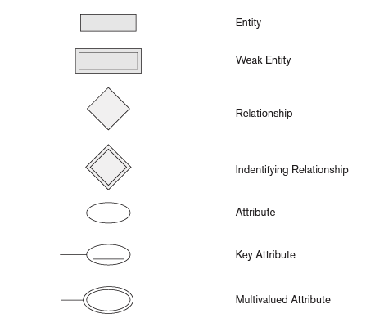

Figure 1

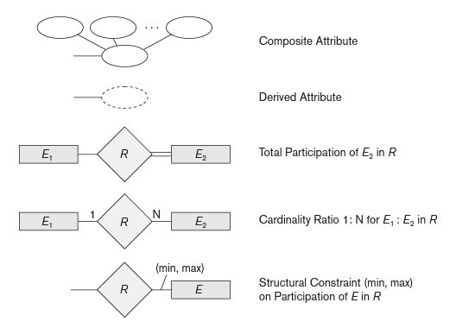

Figure 2

**Demo Problem:**

1. Create an ER Diagram for an E-Bike dealership. Dealer businesses are described by dealer_id, address and name. The dealers sell both E-bikes, and it operates a service facility. Base your design on the following business rules:

* A salesperson may sell many vehicles, but each two-wheeler is sold by only one salesperson. A salesperson details such as employee_id, f_name, l_name are stored
* A customer may have his/her vehicle/s serviced or buy a vehicle/s. Customer details such as f_name,l_name, customer_id, address, phone_number, mail_id are collected
* A customer may buy many two wheelers, but each vehicle is bought by only one customer.
* On successful selling, the salesperson generates an invoice to the customer for each vehicle sold.
* Each invoice generated records customer id, vehicle id (VID), salesperson_id apart from the invoice_no, amount and date
* A customer can seek service or repair for multiple vehicles. A service ticket is generated for each vehicle.
* E-Bike details include VID, registration_num, chassis_number, color,make, model, price and year_of+manufacture
* A vehicle service is identified by a service ticket and is overseen by one service manager. Many such service tickets may be assigned to one service manager.
* A vehicle service may or may not need parts (e.g., adjusting a break liver or cleaning a brake pads does not require providing new parts)
* Assume suitable attributes wherever not given

**Tools used:** Use any free online tools such as Lucid Chart / Smart Draw/ or any simple drawing software

**Solution:**

**List of entities with attributes:**

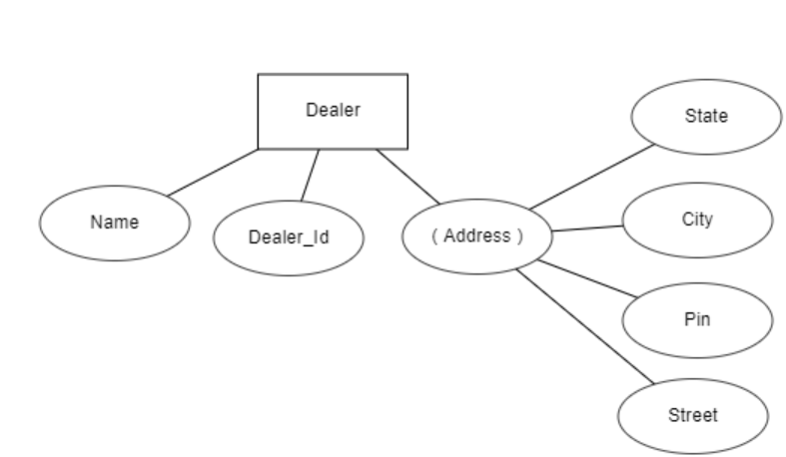  
(Address) indicates that it is a composite attribute  
  
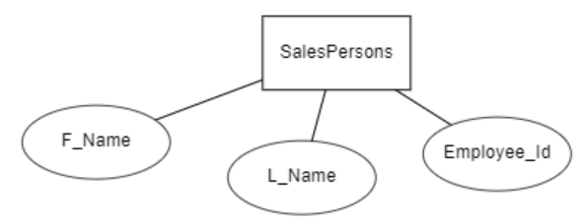

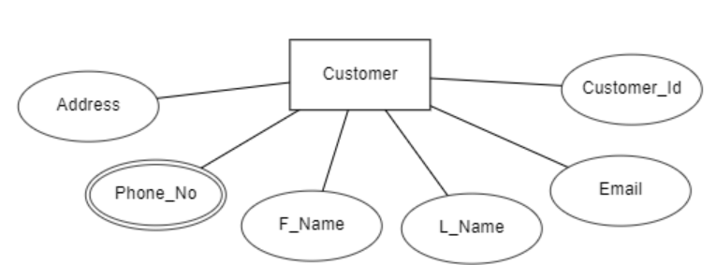

Phone_No is a multivalued attribute

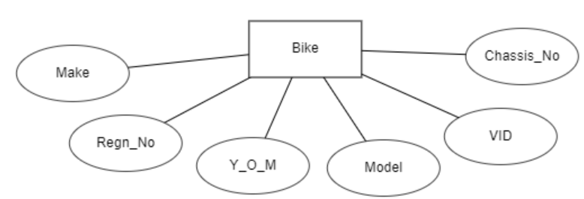

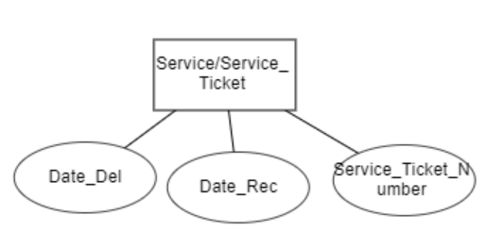

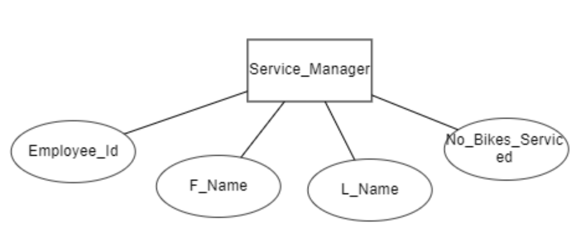

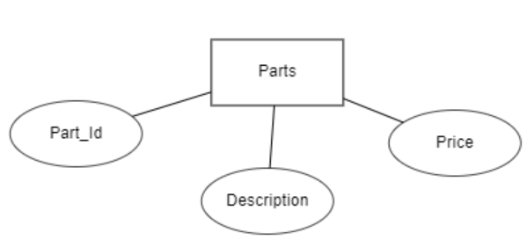

**List of relationships with cardinality, restrictions, weak relationships, weak entities:**

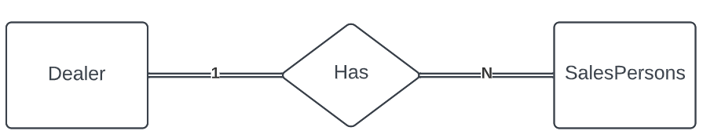

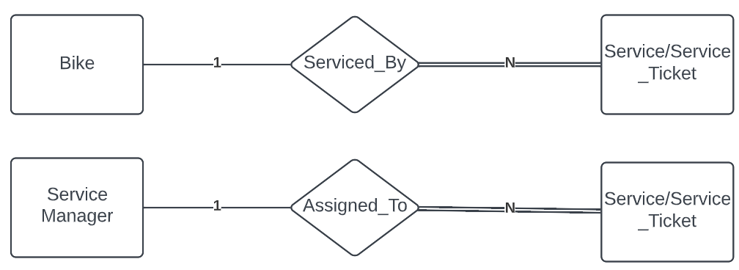

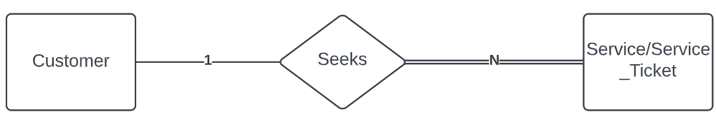

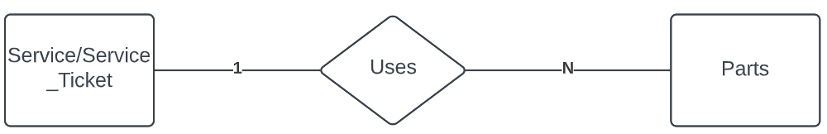

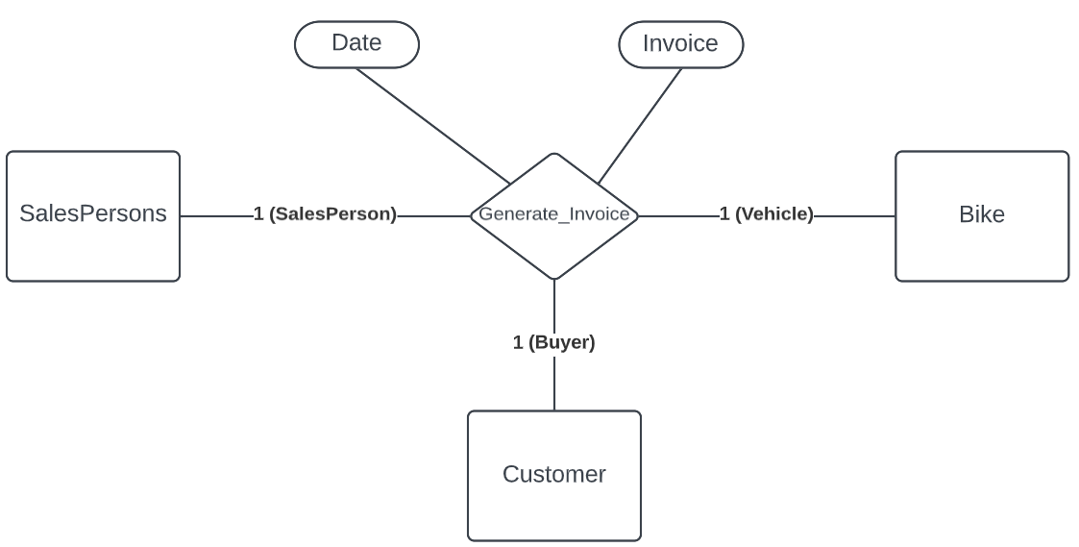

**ER Diagram:**

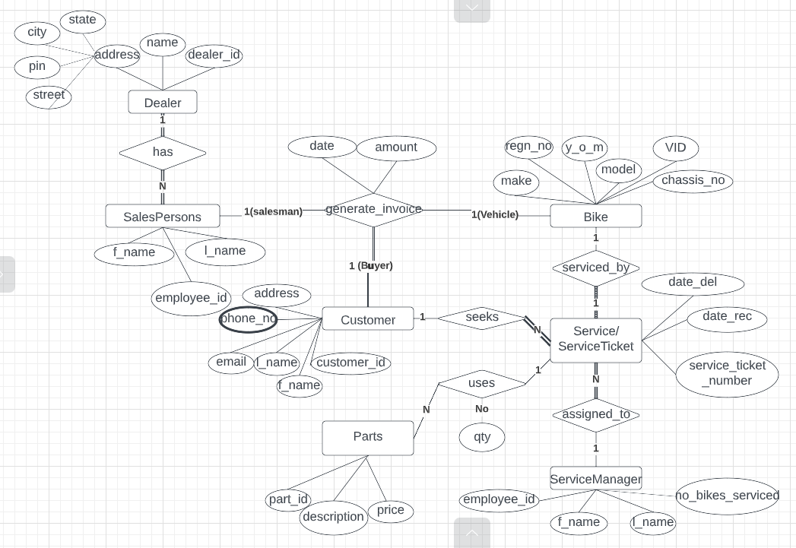

**b**

**Assignment:**

**Railway Reservation System**

Users check for availability of seats/Fare etc. in Trains and also books / cancels Train Tickets from particular source stations to destination stations. An user may be an admin (reservations clerks) or a passenger.

Every train has at least one compartment and at most 5 compartments. Each compartment is of type I class/ II Class / III Class corresponding to the ticket class. Number of seats in each type of compartment is fixed and is equal to 16 , 30, and 60 respectively.

Every train has associated route information that stores distance between each pair of stations along the route

Tickets compute fare from a Fare table that stores fare per KM rate for a given type of train (Superfast, Fast and Mail), for each class of ticket (I /II/ III Class)

Every ticket booked/canceled has associated payment information.

Identify entities and relationships, weak entities, Identifying relationships, total relationships, cardinalities and restrictions of each relationship.

**Deliverables**

1.jpg - Screenshot of all strong entities and weak entities with proper notation

2.jpg - Screenshot of list of Relationships ( with cardinality, restrictions, weak relationships, weak entities indicated with proper notation)

3.jpg - Final ER Diagram

**Prerequisites:**

1. Any online tool for drawing ER Diagram example: smartdraw, ERWin, LucidChart

**TASK A:** Identify all entities in the problem domain. Draw weak and strong entities with proper notations. Show attributes for each entity and denote composite, multivalued and derived attributes. Take a screenshot and name it 1.jpg

**TASK B:** Identify all relationships between the entities. Mark the cardinality ratios, structural constraints, total participations, identifying relationships with proper notations. Take a screenshot and name it 2.jpg

**TASK C:** Draw the ER Diagrams connecting all entities and relationships**.** Take a screenshot and name it 3. Jpg

Zip all three files and name the zip file as yourSRN_Lab1.zip and submit on EDMODO